**Assignment 1: Initialize a new Git repository in a directory of your choice. Add a simple text file to the repository and make the first commit.**

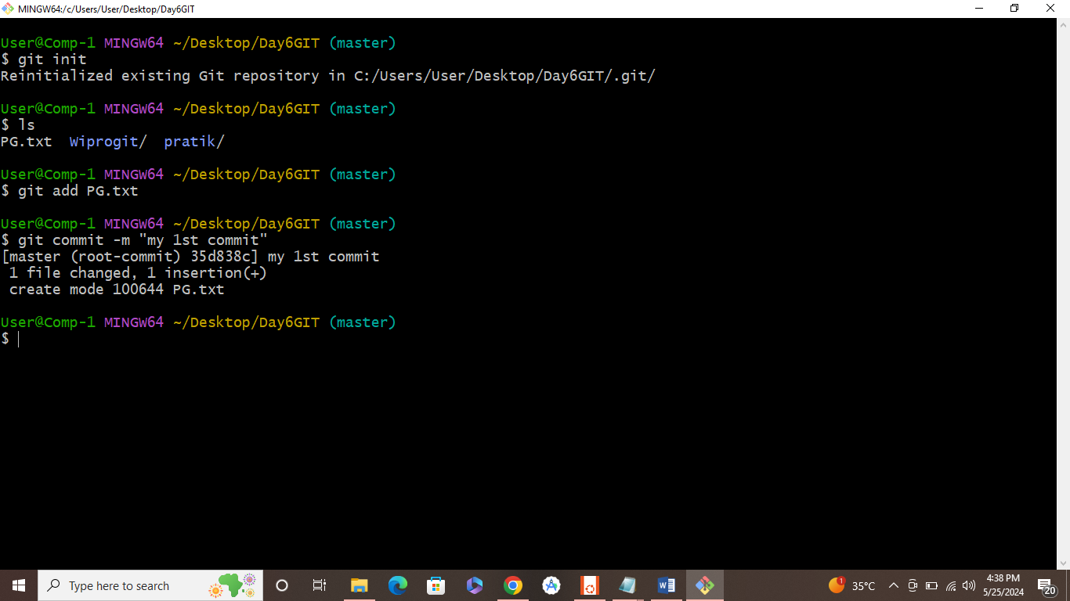

**Assignment 2: Branch Creation and Switching**

**Create a new branch named 'feature' and switch to it. Make changes in the 'feature' branch and commit them.**

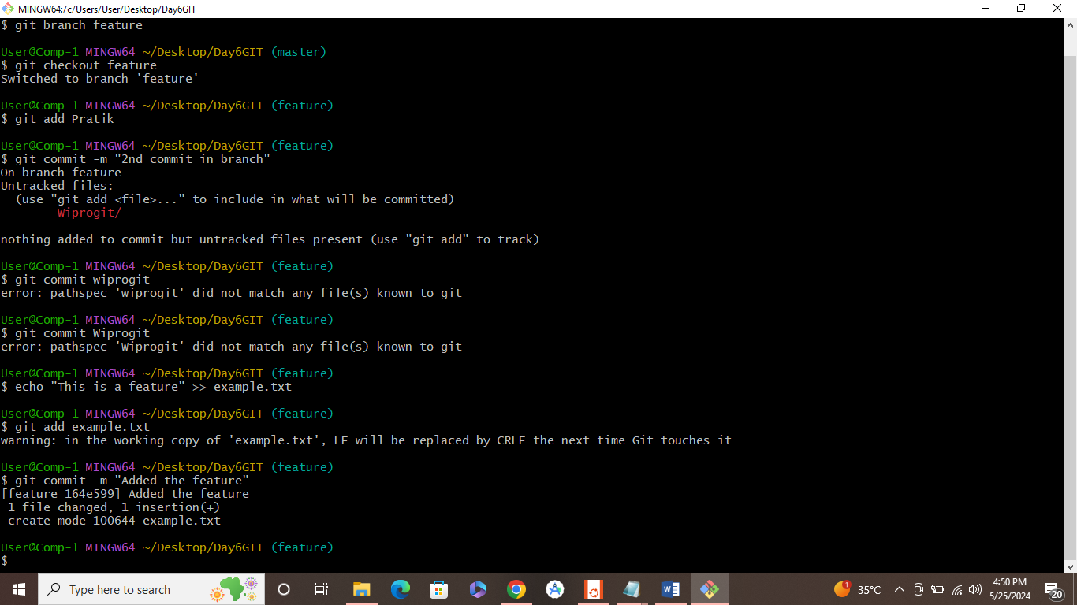

**Assignment 3: Feature Branches and Hotfixes**

**Create a 'hotfix' branch to fix an issue in the main code. Merge the 'hotfix' branch into 'main' ensuring that the issue is resolved.**

